Name: Shriharsh S Kotecha
Reg No: 22MIC0021
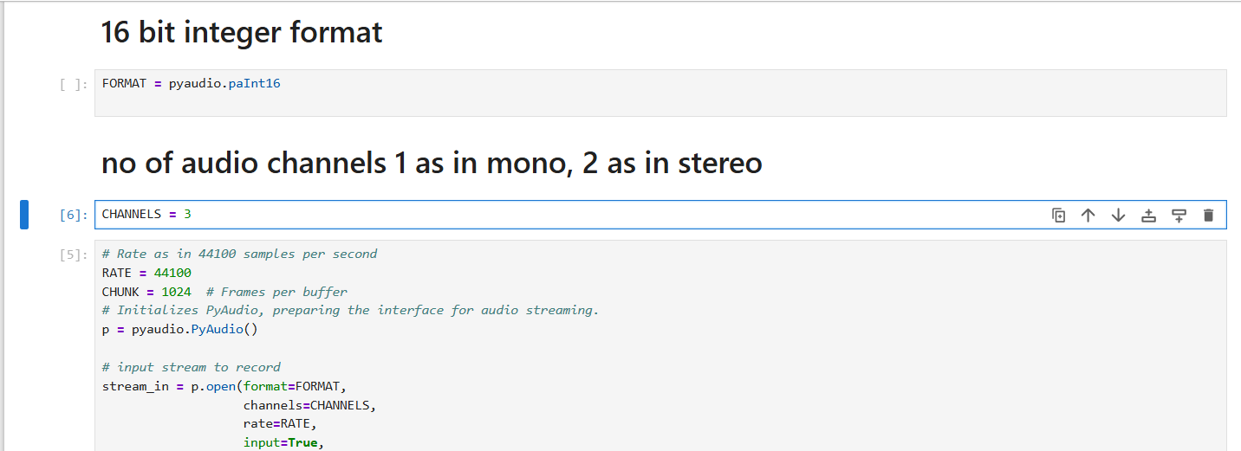
When channels=3, it does does not take throw error but won’t run, so to run properly set CHANNELS as 1 or 2 always not more than that mono for 1 and stereo for 2.

